Report of Software Architecture

Experiment 6: Command Pattern

Basic information
Team name： _______________________________

Class number: ____________________________________________________
Department/school：
Team members with student numbers：

_______________________

Instructor’s comments and score
comments：

score：
signature of the instructor：

Year month date

Homework descriptions：
See the diagram below for a example 11.3 designed by using the Command pattern. Run the source code before you do anything.
作业描述：
请参阅下图，了解使用Command模式设计的示例11.3。
在做任何事情之前运行源代码。
<<interface>>
Command
execute (JPanel panel)
ListenerInvoker
actionPerformed(ActionEvent e)
<<creates>>
<<uses>>
GFan
+startRotate()
+stopRotate()
<<uses>>
<<creates>>
GWindow
+open()
+close()
FanOnBtn
execute()
FanOffBtn
execute()
WindowOpenBtn
execute()
WindowCloseBtn
execute()
ActionListener
ClientUI
<<uses>>
<<uses>>
Homework requirement: Below is the graphical user interface by running the program. In the figure below, add two buttons named “Aircondition On” and “Air Condition Off”. 作业要求：下面是运行程序的图形用户界面。
在下图中，添加两个名为“空调打开”和“空调关闭”的按钮。
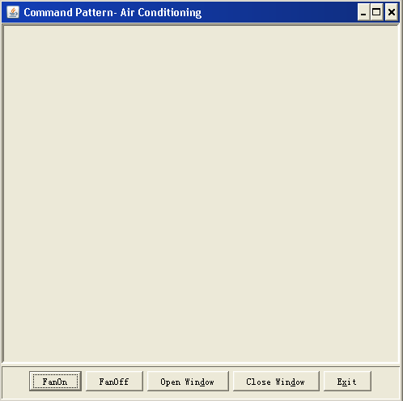

You also need to add a class named AirconditionOnBtn and a class

AirconditionOffBtn. If a user click the “Aircondition On” button, then
the upper part of the GUI shoud become blue and if a user click the “Air

Condition Off” button, the upper part of the GUI shoud become pink.

Note: You need to add another class named GAirConditioner into this
design, in which the above mentioned “blue” and “pink” functionalities
should be implemented. You need to write code for all the newly added
classes mentioned above.
您还需要添加一个名为AirconditionOnBtn的类和一个
空调OffBtn。
如果用户单击“空调打开”按钮，则
GUI的上部应变为蓝色，如果用户单击“空气”
“条件关闭”按钮，GUI的上部应变为粉红色。

注意：您需要将另一个名为GAirConditioner的类添加到此
设计，其中具有上述“蓝色”和“粉色”功能
应该实施。
您需要为所有新添加的内容编写代码
上面提到的类。

- Draw your new class diagram here
1.在这里画你的新类图

- Describe your new design, including
    - What classes have been added to the existing class hierarchy?
    - The relationship between the existing classes and the newly added classes.
2.描述你的新设计，包括
a） 哪些类已添加到现有的类层次结构中？
b） 现有类和新添加类之间的关系。

- If a user clicks on the button “Aircondition On”, what methods in what classes have been invoked. List them in correct order.
如果用户点击“空调开启”按钮，则调用了哪些类中的哪些方法。
按正确的顺序列出它们。

Typical input and output from running your program
Write down typical inputs and outputs for program execution
4.运行程序的典型输入和输出

